**Step 1: Add a step to your GitHub Action to get the S3 URL**

After your Allure report is uploaded to S3, you can easily capture the **S3 URL**:

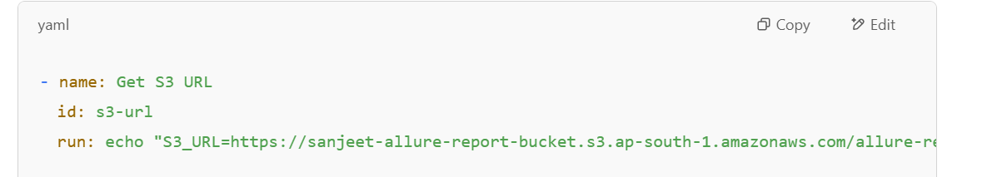

**Step 2: Send to Slack**

Add this step to your GitHub Actions:

<https://app.slack.com/client/T08HZSPFRT5/C08HWPJR7PF?entry_point=help_center&geocode=en-in>

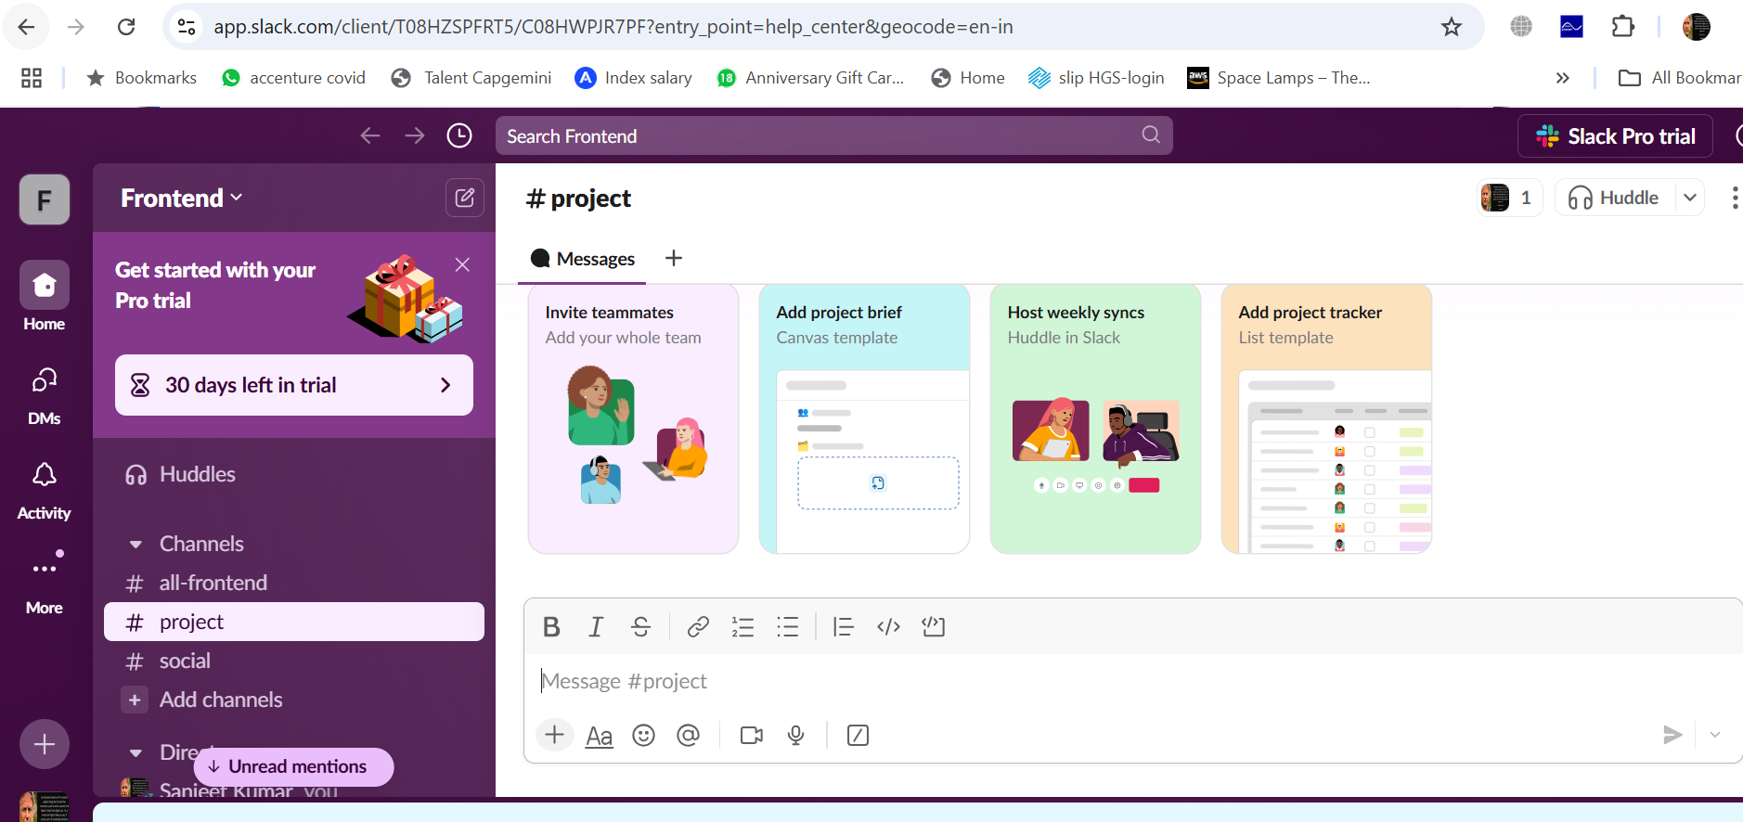

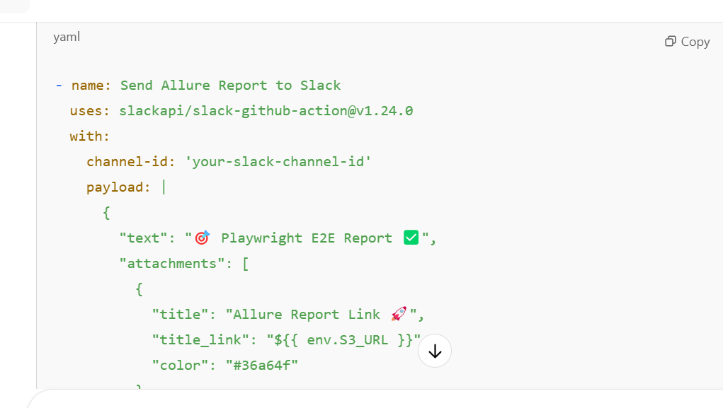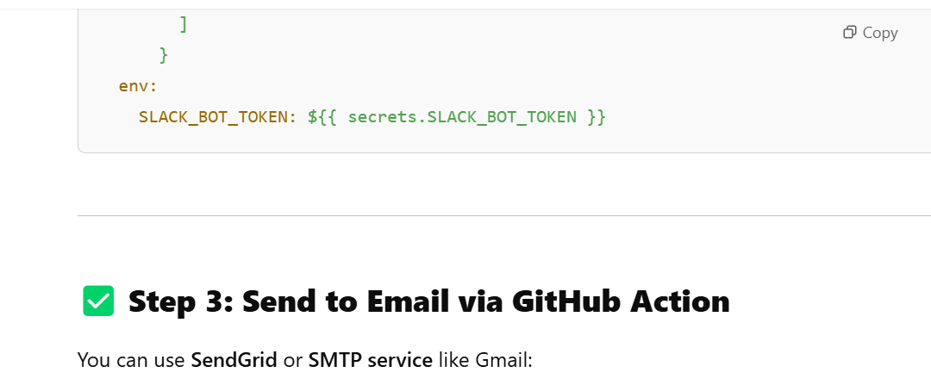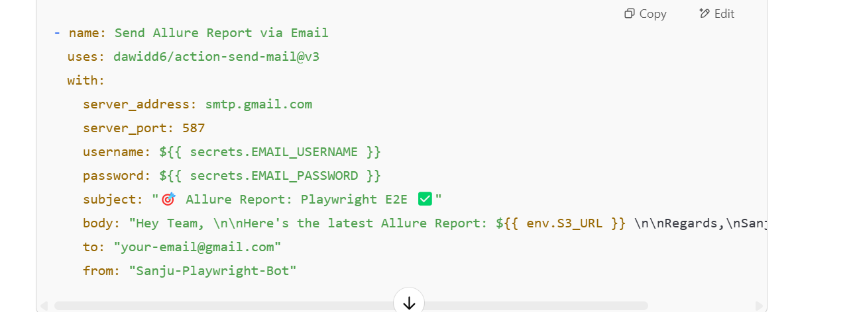

In GitHub Actions, **${{ secrets.YOUR_SECRET_NAME }}** is used to securely **store sensitive information** like **API keys, passwords, tokens, etc.**

**✅ For this Send Email step:**

* EMAIL_USERNAME: Your Gmail or SMTP username (like sanjeetkumarit@gmail.com)
* EMAIL_PASSWORD: Your **App Password**, not your actual Gmail password (I'll show how to get this).

**How to set GitHub Secrets?**

1️⃣ Go to your GitHub repository  
2️⃣ Click on **Settings** ➜ **Secrets and variables** ➜ **Actions**  
3️⃣ Click on **New repository secret**  
4️⃣ Add two secrets:

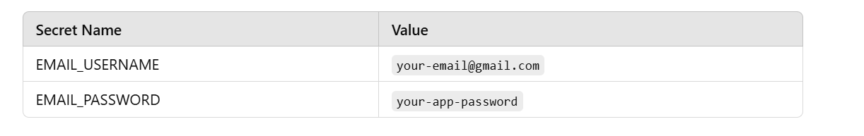**How to get Gmail App Password?**

1. Go to **Google Account Security Settings**: Click Here
2. Enable **2-Step Verification**
3. Under **App passwords**, create a **new app password for "Custom App"**
4. Copy the **16-character password**, and save it in GitHub Secrets